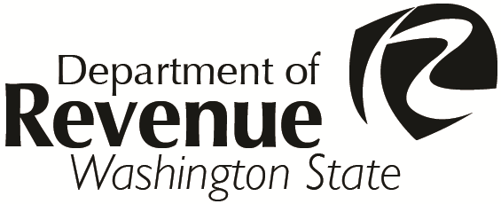
Department of Revenue

Request for Administration of
Appraiser Examination
SECTION I |  |  |  | Please Print or Type
Applicant’s Name:
Last First Middle
Mailing Address:
City: |  |  |  |  |  |  |  |  |  |  | State: |  |  |  |  |  |  | Zip Code:
E-mail Address: |  |  |  |  |  |  |  |  |  |  |  |  |  |  | Work Phone:
Employed by: |  |  |  |  |  |  |  |  |  |  |  |  | County Assessor’s Office
 |  |  |  |  |  |  |  |  |  |  |  |  | Other (please note)
SECTION II |  |  |  |  | Accreditation Examination Request
WAC 458-10-030(1) requires as a prerequisite to taking the accreditation examination, that the applicant shall submit evidence that within the previous two years, a minimum of thirty (30) classroom hours have been successfully completed in courses approved by the Department of Revenue in the basic principles of real property appraising.
I meet the prerequisites noted and I am requesting the Accreditation Examination (Code E001).
I have attached a completed Application for Accreditation as an Ad Valorem Real Property Appraiser, REV 64 0081, to this application: Yes No – if no, please document the following:
➢ 30-classroom hours of courses approved by the Department.
➢ Attach copy of certificate of completion (or college transcripts) for each course listed.
Course Title |  |  |  |  |  |  |  |  |  | Course Sponsor |  |  |  |  |  | Dates Attended |  |  |  |  | Classroom  Hours
SECTION III |  |  |  |  |  | Check Preferred Test Location and Enter the Exam Date
Everett Spokane
Olympia Vancouver
Richland Wenatchee Preferred Exam Date:
If the examination is failed, it may be attempted again after a 60-day waiting period.
 | Applicant’s Signature |  |  |  |  |  |  |  |  |  |  |  |  |  |  |  |  | Date
Return to:

Department of Revenue
Property Tax Division
PO Box 47471

Olympia WA 98504-7471

Phone: (360) 534-1361 or 534-1360
Email:DORPropertyTaxEducation@dor.wa.gov
To ask about the availability of this publication in an alternate format for the visually impaired, please call (360) 705-6715. Teletype (TTY) users, please call (360) 705-6718. For tax assistance, call (360) 534-1400.
REV 64 0080 (01/30/19)

