

If You Have Questions

For questions about these Guidelines or other personal and industrial property tax issues, contact:

Name | Title | Phone Number | E-Mail Address
Pete Levine | Personal Property Supervisor | (360) 534-1423 | PeteL@dor.wa.gov
Howard Hubler | Property Tax Specialist | (425) 984-6450 | HowardH@dor.wa.gov

To access the 2013 Personal Property and Industrial Valuation Guidelines:
- Go to the Department of Revenue’s web site at www.dor.wa.gov.
- Select Find taxes and rates on the left side of the screen.
- Select Property tax below the Find taxes and rates heading.
- In the middle page under How do I… scroll down and select Get property tax statistics, laws and rules, and other resources.
- Select Property tax publications in the center of the screen.
- Scroll down and select either Personal Property Valuation Guidelines or Industrial Valuation Guidelines in the center of the screen.
- Select 2013.
Table of Contents

If You Have Questions 1
Valuation Tables – MS Excel Link 2
Purpose and Use of These Guidelines 3
Minimum Value Percent Good Factors 4
Computers and Peripherals and Microchip Manufacturing M&E 4
Other Exceptions to the Minimum Value Percent 5
Notable Revisions and Clarifications to the 2013 Guidelines 5
Additional Comments 5
Possible Areas for Study in 2013 6
Suggesting Updates to the Guidelines 6
Additional Information and Personal Property Resources 7
Index to Trended Investment Valuation Indicators 8-14
Supplemental Valuation Table 'A' 15

Valuation Tables – MS Excel Link

 Double click on the MS Excel icon in the box below to access the “2013 Personal and
Industrial Property Valuation Tables.”

Included in the link – in the box below – to the Excel file are the following worksheets and the respective tables:

CLICK BELOW

“2013 Personal and Industrial Property Valuation Tables”

- 2013 Combined Tables (All)
- 2013 Trend I Table
- 2013 Trend II and III Tables
- 2013 Building and Land Improvements Table
- 2013 Title Plant (Supp B)
- Informational – 2013 Trend with Freeze
- Informational – Declining Balance Table

Purpose and Use of These Guidelines

The Department of Revenue publishes these valuation guidelines to assist county assessor’s offices in estimating 2013 assessed values for tangible personal and industrial property. The Department recommends assessors consider these guidelines in the valuation process in order to promote and contribute to statewide uniformity and standardization in the assessment of personal property.

The guidelines are based on typical physical depreciation and functional obsolescence for assets that have been maintained in average condition. When the appraiser or auditor is aware of market conditions or has other evidence, adjustments to the estimated market values can be made, as the guidelines do not reflect abnormal or extraordinary obsolescence that, when identified, should be considered separately. Data and information must be able to substantiate any excessive obsolescence not already considered in the indicators.

To use the guidelines:
Step #1 – Find the class/type of property in the alphabetical index and note the indicated Trend/Column for that class/property type.
Step #2 –Find the corresponding Trend/Column the Index refers you to in the Combined Table.
Step #3 – Using the Combined Table, locate the “percent good factor” at the intersection of the acquisition year row and the indicated table/column for the property being valued.
Step #4 – Using the property owner’s personal property listing information; multiply the historical (or original) cost by the “percent good factor” to arrive at an estimated value as of January 1, 2013.

Example: Consider an office desk and chair (i.e. Furniture & Fixtures) purchased in 2009 for $1,000

Steps #1 & #2
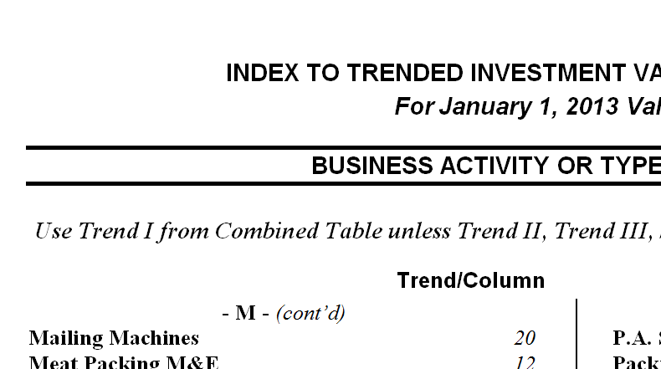
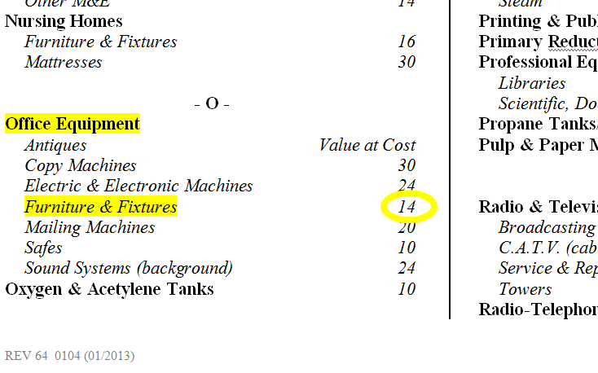

Step #3
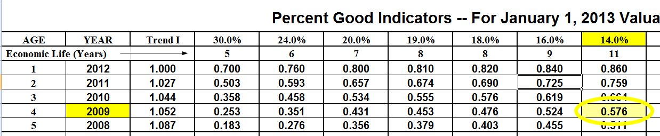

Step #4
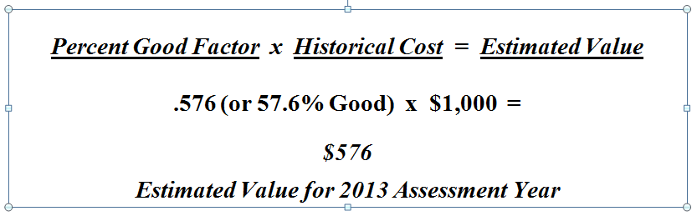

The historical or original costs listed by the property owner need to include both hard and soft costs – such as interim financing during installation or construction, engineering, freight, installation, and any other costs necessary to put the equipment in to service. The only exclusion is that the sales or use tax is removed when valuing personal property. If assets are installed in such a way that they become fixed to the real property, or their removal would cause significant damage to the real property, the assets might be regarded as real property. As real property, the sales tax should be included as a cost that adds value to the assets, except when there is a sales or use tax exemption that applies to qualifying manufacturing machinery and equipment as of the assessment date.

Minimum Value Percent Good Factors

Please note that these guidelines are intended for estimating the value of property that is “in use.” The minimum value percent or factor is 15 percent, unless otherwise noted, as shown on the Combined Table and is intended to reflect the value of assets for as long as they are in use (Fair Market Value In Continued Use). For assets not in productive use (such as those in storage), freight and installation may be excluded from the cost basis to determine the value.

Computers and Peripherals and Microchip Manufacturing M&E
Most percent good factors on the Combined Table indicate a minimum value of 15 percent good, however, several exceptions exists. Personal computers (and peripherals including digital cameras and recorders) decline to 2 percent good, and two of the Microchip Manufacturing M&E categories decline to 5 percent good. In addition, network computer equipment and mainframes are valued using the Trend II “N” table, which declines to 5 percent good.

Other Exceptions to the Minimum Value Percent
When the appraiser or auditor is aware of market conditions or has other evidence (including, but not limited to, direction from court or board proceedings) to apply percent good factors below 15 percent, rates can be calculated and applied. Evidence must reflect the value in continued use at the retail trade level, as well as documented data and information must exist to substantiate a floor less than 15 percent.

Notable Revisions and Clarifications to the 2013 Guidelines

Several “Business Activity or Type of Business” indexes were revised to provide clarification and update some terminology. The revisions result from matters brought to our attention from stakeholders throughout the previous year, as well as inquiries requesting clarification. In some instances, revisions include updated studied industry information and available data. For some instances, revisions may reflect advice the Department has provided for the assessment of particular equipment, utilizing the best information available for the appropriate economic life, until additional information becomes available or until further study of the equipment.
- Notable revisions, clarifications, or added indexes made for 2013, included the following:
Business Activity or Type of Business Trend/Column
Agriculture
Combines 16
Orchard Wind Machines 12
Cranes
Bridge / Gantry / Jib 8.5
Electrical Generating
Solar Panels (Photo Voltaic type) 8.5

Additional Comments

- For 2013, the Department’s recommendation for locally assessed Wind Turbines (Wind Farms) M&E remains unchanged, recommending continued use of the 8.5 percent Trend 1 column. The table applies to the historical cost, after deducting the actual Investment Tax Credit (ITC), typically 30 percent for qualifying property – if applicable. Property owners need to report the entire historical cost, noting whether an ITC was claimed – if claimed, the assessor will adjust the historical cost to reflect the ITC before applying the 8.5 percent table.
Locally assessed wind turbines are seldom assessed as part of the real property, as they are generally personal property – by definition, trade fixtures [WAC 458-12-005(2)(i)]. Keep in mind the historical (or original) costs include both hard and soft costs (such as interim financing during installation or construction, engineering, freight, and installation) and are to be included as part of the cost to which the factors are applied. The only exclusion from cost is that the sales or use tax is removed when valuing personal property. The Department advises that property owners report all costs associated with the wind turbine project, and the Assessor will determine what is personal or real – by doing so, the Assessor can ensure to avoid double assessments while avoiding any omitted property, or omitted value.
The 2013 recommended guideline for valuing locally assessed wind turbines will continue to be reviewed annually, when additional information and data becomes available. If the appraiser or auditor is aware of market conditions or has other evidence, adjustments to the estimated market values can be made, as the guidelines do not reflect abnormal or extraordinary obsolescence that, when identified, should be considered separately. Data and information must be able to substantiate any excessive obsolescence not already considered in the indicators.
- The Department included Solar Panels (Photo Voltaic type), when assessed as personal property with an 8.5 percent Trend 1 column table. Current project data is limited and the guidance reflects a table with estimated economic life from the industry information. As well, the appraiser will need to consider potential influences with investment tax credits, similar to wind turbines. The Department recommends reporting the historical (or original) costs, which include both hard and soft costs (such as interim financing during installation or construction, engineering, freight, and installation), and whether or not Investment Tax Credits (ITC) were taken.
- For 2013, the Department continues to recommend existing guidance for the valuation of Cable and Satellite Television Systems.

Possible Areas for Study in 2013

The Department regularly considers revisions to the guidelines, and would like additional and continued review during 2013, for the following:
- Billboards and Poster Panels
- Cable and Satellite Television Systems
Review will include inviting stakeholders input for calibrating the tables for the indexes studied. If you would like to be part of the discussion to provide feedback, data, or information related to these areas, please contact Pete Levine, Personal Property Supervisor, at PeteL@dor.wa.gov.

Suggesting Updates to the Guidelines

As always, we continually invite input to the guidelines at any time during the year and attempt to incorporate suggested ideas when annually updating the guidelines, keeping in mind the needs of all stakeholders. If you would like to make any suggestions or provide feedback throughout the year, please consider the following questions below, and e-mail your responses to PeteL@dor.wa.gov.
- Generally, what needs to be fixed, added, or deleted in the Guidelines? Why? What do you recommend?
- Are there any guideline business activities in the indexes or tables that need to be revised? Why? What do you recommend, and what data can you provide to substantiate the revision?
- Are there any types of assets or business activities not listed in the index that should be listed? If so, which ones? Why?
- Do you have data about any assets, business activity, or type of business that might help recalibrate an existing guideline?
Please provide any data or studies you have, as it is useful as we consider the information for updating the guidelines in the future. If you have any additional questions or comments, feel free to contact Pete Levine directly at 360-534-1423.

Additional Information and Personal Property Resources

- Personal Property Tax Information Video – http://dor.wa.gov/Content/Home/VideoHub/hubfiles/1a.html
- Personal Property Tax Brochure – http://dor.wa.gov/docs/Pubs/Prop_Tax/PersProp.pdf
- Property Tax Review (newsletter) articles related to personal property assessment:
  - Allocated vs. Historical Cost – http://dor.wa.gov/Docs/Pubs/Prop_Tax/NewsletterSept2008.pdf
  - Closed Business Required to File? – http://dor.wa.gov/Docs/Pubs/Prop_Tax/NewsletterSpring2007.pdf
  - Fixed Loads vs. Part of Vehicle – http://dor.wa.gov/Docs/Pubs/Prop_Tax/Winter2012Newsletter.pdf
  - Head of Family Exemption – http://dor.wa.gov/Docs/Pubs/Prop_Tax/NewsletterSpring2007.pdf
  - Leased Equipment FAQs – http://dor.wa.gov/Docs/Pubs/Prop_Tax/NewsletterSpring2009.pdf
  - Rental Equipment FAQs – http://dor.wa.gov/Docs/Pubs/Prop_Tax/NewsletterSpring2010.pdf
  - Taxability of Software – http://dor.wa.gov/Docs/Pubs/Prop_Tax/Winter2012Newsletter.pdf
  - Timeshare Assets – http://dor.wa.gov/Docs/Pubs/Prop_Tax/NewsletterSummerFall2012.pdf
  - Title Plant FAQs – http://dor.wa.gov/Docs/Pubs/Prop_Tax/Spring2011Newsletter.pdf
  - Watercraft: Exempt or Not? – http://dor.wa.gov/Docs/Pubs/Prop_Tax/Summer2011Newsletter.pdf
  - Websites: Personal Prop? – http://dor.wa.gov/Docs/Pubs/Prop_Tax/NewsletterSummerFall2012.pdf

Index to Trended Investment Valuation Indicators

- A -
Agriculture
Aqua Farms
Nets 30
Pens & Support Structures 18
Combines 16
Dairy Milking M&E 14
Feed Mill M&E (production line) 7.5
Feed Mill M&E (portable) 12
Fertilizer & Chemical Applicators
Dry Fertilizer Spreaders 18
Liquid Fertilizer & Chemical Sprayers 24
Manure Systems - Liquid 24
Hay Equipment, Hay Tarps 18
M&E (excluding Tractors & Dairy) 18
Mint Stills & Tubs 18
Irrigation Systems
Circles 18
Gated Pipe 18
Wheel Moves & Handlines 16
Orchard Wind Machines 12
Seed Cleaning M&E 7.5
Seed Cleaning M&E (portable) 12
Tanks (agricultural) 16
Tractors 12
Unlicensed & Licensed Farm Vehicles including 16
Trailers (permanently sited and/or not primarily designed for use on public streets and highways;
see PTA 6.2.2011, “Property Taxability of
Motor Vehicles”)
Air Conditioning (single room unit) 16
Aircraft Manufacturing M&E 7.5
Aircraft Manufacturing (small parts mfg.) 14
Testing Equipment 24
Small Tools (perishable) 24
Patterns 24
Aircraft Parts Manufacturing
M&E 14
Test Equipment 24
Small Tools 24
Amusement Devices (Music Machines, etc.) 24
Video DVDs, BluRay, & Games Supplemental A
Antique F&F Value at Cost
Apartment F&F 16
Appliances (Household Type i.e., refrig., dishwasher, range/oven, microwave, washer/dryer, etc.) 19
Apparel Manufacturing M&E 8.5
Aqua Farms
Nets 30
Pens & Support Structures 18
Archery Equipment Manufacturing 12
Artwork Value at Cost
Auto Repair (also see Grocery & Conv Stores/Gas St)
Diagnostic Equipment (electronic) 24
M&E 18
Small Tools 24
Welding Equipment 12
Average Manufacturing M&E 7.5

- B -
Bakeries
Industrial (i.e., wholesale bake goods mfg) 8.5
Commercial (i.e., grocery store bakery) 12
Banks
Alarm Systems 24
ATM/Cash Machines 24
Furniture & Fixtures 14
Portable Safes or Vaults 10
Safety Deposit Boxes 10
Vault Doors Value at Cost
Video Equipment 24
Barber & Beauty Shop 16
Baseboard Heater Manufacturing M&E 12
Beer Kegs 10
Billboards Supplemental A
Bleach Manufacturing M&E 7.5
Bleach Packaging M&E 14
Blueprinting, Photostatting, Mimeographing, 16
& Lithograph (non-electronic)
Boat Molds (fiberglass) 24
Book Bindery 12
Bottling & Soft Drinks Manufacturing M&E
Beverage Canisters/Cylinders (i.e., Pre-Mix 10
Soda Pop)
CO2 Tanks/Cylinders 10
Free standing, not part of a production line 14
Part of production line 10
- B - (cont’d)
Bowling Alleys 12
Electronic Scoring Machines 24
Pinsetters & Others 19
Brewing & Distilling 10
Building & Land Improvements
Building Classes C, D, or S B&LI Trend/4
Chemical Buildings B&LI Trend/6.5
Long-lived Imprv’s (asphalt paving, fencing, etc). 10
Short-lived Imprv’s (carpet, fixtures, etc.) 16
Butcher Shops 12

- C -
C.A.T.V. (Cable Systems) & S.A.T.V. Equipment
Converters, Decoders, Digital Boxes, Modems 30
Distribution Equipment 14
Electronic Testing Equipment and Small Tools 24
Headend Equipment 16
House Drops 14
Signal Receiving Equipment 12
Television Production Equipment 19
Cabinet Shop M&E 12
Campground Equipment 16
Candy & Confection Manufacturing M&E 12
Car Wash (i.e. 5 Min. & Coin-Op) 18
Cash Machines 24
Cash Registers & Scanners 24
Casino Equipment
Game Type (F&F, i.e,. blackjack table, 19
roulette wheel, etc.)
Video Type 24
Cell/Wireless Telephone – Tower Only 7.5
Cell/Wireless Telephone – Tower & Antenna 12
Cell/Wireless Telephone – Antenna Only 24
Cement, Clay, & Brick Products Mfg. 7.5
Chemical Products Manufacturing 8.5
Clothing Manufacturing 8.5
Cocktail Bars & Taverns 19
Antique Back Bars Value at Cost
Coin-Op Lockers 16
Coin-Op Machines 24
Computer Cabling
Cabling to local peripherals-minor cabling Trend II/C
Permanently installed-major network cabling 16

Computer Systems (Business)
Canned Software Supplemental A
Custom Software Supplemental A
Lotto Machines 30
Mainframe Computers, Disk Array and other Storage Devices, and Network servers Trend II/N
Personal Computers (Including desktop and/or laptop computers and peripheral/connected hardware. E.g., scanner, printer, and multifunction digital printer/scanner/fax machine combo.) Trend II/C
Production Systems Computers (with direct
electronic link to longer-lived equipment.) 24
Computer Numeric Controlled (CNC) Trend III/MM
Milling Machines & Lathes (freestanding, not part of a production line & the CNC hardware component
is integrated within the milling machine)
Construction M&E
Asphalt Plants
Portable 18
Stationary 12
General Construction 16
Land Clearing (i.e., backhoe, excavator 16
crawler, grader, etc.)
Marine Construction
Ships & Vessels (production line) 7.5
Ships & Vessels (portable equipment) 12
Pleasure Craft 12
Boat Molds 24
Road Construction-Heavy (i.e., asphalt grinder, 24
large off-highway truck, etc.)
Rock Crushing
Portable 18
Stationary 12
Sewer & Utilities 16
Unlicensed & Licensed Vehicles including Trailers 16
(permanently sited and/or not primarily designed for use on public streets and highways; see PTA 6.2.2011, “Property Taxability of Motor Vehicles”)
Well Drilling 16
Container Manufacturing M&E 7.5
Convenience Stores (see Grocery&Conv Stores/Gas St)
Coolers
Reach-in Coolers & Freezers 16
Walk-in Coolers & Freezers 12
- C - (cont’d)
Copy Machines 30
Costumes (rental) 24
Cranes
Bridge/Gantry/Jib 8.5
Container 8.5
Crawler 10
Mobile Telescopic 16

- D -
Dairy Milking M&E 14
Dairy Processing 10
Data Processing Equipment 30
Day Care (excludes office, kitchen, & computer assets) 24
Dental
Equipment 14
Furniture & Fixtures 14
Libraries 12
X-Ray Equipment 18
Department Store F&F 16
Dies & Molds 18
Electronic Manufacturing 24
Patterns 24
Digital Cameras and Recorders Trend II/C
Dispensing Machinery (coin-op) 24
Distilling & Brewing 10
Doctors Offices & Health Clinics
Diagnostic Equipment (electronic) 24
Equipment 14
Furniture & Fixtures 14
Libraries 12
X-Ray Equipment 12
Drug Store F&F 16
Dry Cleaning & Laundry M&E
Coin-Op 24
Other than Coin-Op (excluding household type) 14
Dumpsters, Garbage 16

- E -
Electrical Generating
Gas & Diesel (portable) 16
Solar Panels (Photo Voltaic type) 8.5
Steam & Gas fired (fixed equipment) 7.5
Wind Turbines (Wind Farms) M&E 8.5
Electrical Manufacturing M&E 12
Electronic Equipment 24
Electronic Manufacturing M&E 24
Espresso Carts 24
Espresso Machines (includes coffee grinders) 19
Extrusion M&E 12

- F -
Farm Equipment (see Agriculture)
Fax Machines 30
Fax/Phone/Copier Units 30
Feed Mill M&E (production line) 7.5
Feed Mill M&E (portable) 12
Fertilizer Applicators (see Agriculture)
Fertilizer Manufacturing 7.5
Fiberglass Molds (other than boats) 24
Fish Processing M&E (production line & portable) 12
Fitness Equipment
Electronic 24
Manual 16
Flour, Cereal & Grain Milling 7.5
Food Processing
Candy & Confection Mfg M&E 12
Frozen Food Processing M&E 10
Fruit & Veg Processing M&E 10
General Food Processing M&E 10
Meat Packing M&E 12
Meat Processing (complex) 8.5
Potato Processing M&E 10
Seafood Processing M&E 12
Forklifts 16
Foundry 7.5
Foundry Furnaces 6.5
Fraternal Lodges 14

- G -
Gambling Equipment
Video Type 24
Game Type (blackjack table, roulette wheel, etc.) 19
Game Consoles (Playstation, Wii, Xbox, etc.) 24
Garage M&E 18
Garbage – Dumpsters 16
Garbage – Plastic Waste & Recycle Containers 16
Gas Stations (see Grocery & Conv Stores/Gas St)
General Contractor M&E 16
- G - (cont’d)
Generators (gas & diesel) 16
Golf Courses
Carts 20
Equipment 18
Tractors 12
GPS Receivers (portable) 30
Greenhouse & Nursery M&E 16
Grocery & Convenience Stores / Gas Stations
Cash Registers & Scanners 24
Dispensers (gas) 20
Fixtures & Equipment 16
Fuel Tanks B&LI Trend/6.5
Meat Packing 12
POS (Point of Sale computer systems) 30
Public Address Systems 20
Reach-in Coolers & Freezers 16
Walk-in Coolers & Freezers 12

- H -
Hardware Store F&F 16
Hatchery M&E 16
Health Spa Equipment
Manual 16
Electronic 24
Hospitals
Diagnostic Equipment (CT, MRI, ultrasound, etc) 24
Electronic Equipment 24
Equipment 16
Furniture & Fixtures 16
Laboratory Equip. (non-electric) 18
Laboratory Equip. (electronic & computerized) 24
Mattresses 30
X-Ray Equipment 12
Hotels /Motels
Furniture & Equipment (includes mattresses) 19
Office Equipment (see Office Equipment)
Restaurant & Bar Equipment 19
Telephone Systems 30
TVs, Game Consoles, DVD players, etc 24

- I -
Ice Cream Cabinets 16
Ice & Refrigeration Machinery 7.5
Iron & Steel Industry 7.5
- J -
Janitorial Service Equipment 20
Jewelry Store F&F and Equipment 16

- K -
Key Duplication Equipment 16

- L -
Laboratories
Diagnostic 24
Equipment (non-electronic) 18
Equipment (electronic & computerized) 24
Land Improvements & Buildings
Bldg Classes C, D, or S B&LI Trend/4
Chemical Buildings B&LI Trend/6.5
Long-lived Imprv’s (asphalt paving, fencing, etc). 10
Short-lived Imprv’s (carpet, fixtures, etc.) 16
Landscaping M&E 16
Laundry & Dry Cleaning
Coin-Op 24
Other Than Coin-Op (excluding household type) 14
Law Libraries 12
Leather Products Manufacturing M&E 8.5
Libraries (professional) 12
Lift Trucks 16
Lotto Machines 30
Lumber & Wood Products
Logging M&E 18
Log Stackers 18
Pulp, Paper, & Paperboard Manufacturing 7.5
Plywood & Veneer Manufacturing 8.5
Scarifying M&E 18
Sawmills
Portable 14
Stationary 8.5

- M -
Machine Shop M&E (Production Line) 7.5
Machine Shop M&E (Non-Production Line&Lathes) 12
Machine Shop – Milling Machines & Lathes
(freestanding, not part of production line)
Computer Numeric Controlled (CNC)
Milling Machines & Lathes Trend III/MM
Manual Milling Machines and Lathes (non-CNC) 12
- M - (cont’d)
Mailing Machines 20
Meat Packing M&E 12
Meat Processing (Complex) 8.5
Metal Fabrication & Extrusion Mfg. 7.5
Metal Sheet Fabrication (production line) 7.5
Metal Sheet Fabrication (not part of prod. line) 12
Microchip Manufacturing M&E
Printed Circuit Board M&E Trend II/B
Silicon Wafer Fabrication M&E Trend II/N
Product Assembly M&E Trend II/N
Process Support Equipment & Piping Trend II/S
Milling Machines (see Machine Shop)
Mining & Milling 8.5
Mobile Yard Equipment 16
Mobile Trailer Units 16
Mortuary Service Equipment 14
Motels (see Hotels /Motels)
Music Instruments -- Rental 24
Music Studio Recording Equipment 24
Music Systems (background) 24

- N -
Neon Signs 19
Newspaper M&E
Press 10
Photographic 16
Computer (production) 24
Other M&E 14
Nursing Homes
Furniture & Fixtures 16
Mattresses 30

- O -
Office Equipment
Antiques Value at Cost
Copy Machines 30
Electric & Electronic Machines 24
Furniture & Fixtures 14
Mailing Machines 20
Safes 10
Sound Systems (background) 24
Oxygen & Acetylene Tanks 10
- P -
P.A. Systems 20
Packing & Sorting M&E (fruit, vegetable, etc.) 12
The following rates may be applied if owner can document costs to mechanical vs. electronic equipment:
Mechanical portion of the line equipment 10
Electronic portion of the line equipment 24
Paint & Varnish Manufacturing M&E 12
Pallets, Crates, Lugs, Bins, Etc. 18
Petroleum Products
Bulk Station Equipment 14
Petroleum (Bulk Storage) Tank B&LI Trend/6.5
Refining 8.5
Service & Gas Station Equip (see Auto Repair and/or Grocery&Conv Stores/Gas St)
Photography Equipment 16
Computerized Trend II/N
Digital Cameras & recorders Trend II/C
Electronic 24
One Hour Photo Equipment 16
Plastic Manufacturing M&E 12
Plastic Extrusion M&E 12
Plastic Injection M&E 12
Plumbing Shop Equipment 16
Plywood & Veneer Manufacturing 8.5
Pool Hall Equipment 14
Power & Generation M&E
Gas & Diesel 16
Steam 7.5
Printing & Publishing Equipment (see Newspaper)
Primary Reduct 7.5
Professional Equipment
Libraries 12
Scientific, Doctors, Dentists, Etc. 14
Propane Tanks/Cylinders 12
Pulp & Paper Manufacturing 7.5

- R -
Radio & Television Equipment
Broadcasting Equipment 19
C.A.T.V. (cable system) (see C.A.T.V. Equipment)
Service & Repair Equipment 19
Towers 12
Radio-Telephone Equipment 2-Way 24
- R - (cont’d)
Railroad Rolling Stock-Private (except logging cars) 12
Railroad Car Conversions 16
Refrigeration & Cold Storage 8.5
Rental Equipment
Costumes 24
Public U-Rent (excluding Heavy Equipment) 24
Rental of Heavy Equipment (Value by Type)
Rented Medical Equipment (Value by Type)
Telephones (Residential) 30
Tuxedos 30
Research & Development M&E 20
Restaurants, Soda Fountains, & Drive-Ins 19
Walk-in Coolers & Freezers 12
Retail Stores
Cash Registers & Scanners 24
Furniture and Fixtures 16
Office F&F (see Office Equipment)
POS Computer Systems 30
Public Address Systems 20
Sound Systems (Background) 24
Rock Crushers (see Construction)

- S -
Sawmills (see Lumber & Wood Products)
Scaffolding (Rental) 24
Search Lights 18
Security Systems/Cameras 24
Service Stations (see Auto Repair)
Sewing Equipment 12
Sewer Construction Equipment 16
Sheet Metal Fabrication (production line) 7.5
Sheet Metal Fabrication (not part of prod. line) 12
Shipbuilding (see Construction)
Shipyards (see Construction)
Shoes & Leather Products Mfg. M&E 8.5
Signs
Bulletin Boards 14
Billboards Supplemental A
Electronic 16
Neon 19
Plastic Illuminated 19
Poster Panels Supplemental A

Ski Areas
Snow Cats & Packers 24
Tows & Lifts 7.5
Ski Manufacturing Equipment 12
Small Tools (perishable) 24
Smelting 7.5
Soft Drink Manufacturing M&E
Beverage Canisters/Cylinders (i.e., Pre-Mix 10
Soda Pop)
CO2 Tanks/Cylinders 10
Free standing, not part of a production line 14
Part of production line 10
Sound Systems (background) 24
Supermarkets (see Grocery&Conv Stores/Gas St)
Surveying Equipment
Electronic 24
Other Survey M&E (non electronic) 14

- T -
Tanks
Agricultural Tanks 16
Beverage Canisters/Cylinders 10
(i.e., Pre-Mix Soda Pop)
Bulk Petroleum & Chemical B&LI Trend/6.5
CO2 Tanks/Cylinders (&Specialty Gasses) 10
Cryogenic Tanks (part of a M&E setting) 7.5
Gas Station Fuel Tanks B&LI Trend/6.5
Misc Tanks (i.e., above ground, non-com gas/oil) 16
Oxygen & Acetylene Tanks/Cylinders 10
Propane Tanks/Cylinders 12
Winery Tanks 7.5
Tanning Salon Equipment 16
Tavern & Bar Equipment 19
Antique Back Bars Value at Cost
Television & Radio Equip (see Radio & Television)
Television (for entertainment) 24
Telephones
Cellular 30
Fax/Phone/Copier Units 30
Pagers 24
Rentals (commercial & residential) 30
Systems (customer owned) 30
Textile Tent & Awning Mfg. M&E 8.5
- T - (cont’d)
Theatres / Movie & Cinema
F&F 18
Projection Equipment 16
Tire Recapping 14
Title Plants Supplemental B
Tuxedo Rentals 30
Toilets, Portable 14

- U -
Unlicensed & Licensed Vehicles including Trailers 16
(permanently sited and/or not primarily designed for use on public streets and highways; see PTA 6.2.2011, “Property Taxability of Motor Vehicles”)
Upholstery Equipment 16

- V -
Vending Machines 24
Veterinarian (see Doctors Offices & Health Clinics)
Videos (DVDs, Blu-Ray, etc) Supplemental A
Video Arcade Games Supplemental A
Video Cameras/Camcorders 24
Video Game Consoles (Playstation, Wii, Xbox, etc.) 24
- W -
Warehouse Equipment (including pallet jacks) 14
Pallets, Crates, Lugs, Bins, etc. 18
Water Softeners 14
Water Systems 12
Welding Shop Equipment 12
Well Drilling 16
Wind Turbines (Wind Farms) M&E 8.5
Winery Equipment – Production Line (including 7.5
tanks & bottling line)
Winery Equip. – Portable Equip. (e.g., pumps) 14
Aging Barrels Supplemental A
Innerstaves Supplemental A
Wireless/Cell Telephone – Tower Only 7.5
Wireless/Cell Telephone – Tower & Antenna 12
Wireless/Cell Telephone – Antenna Only 24
Wholesale Store 14
Woodworking Shops M&E 12

- X -
X-Ray Equipment (other than Dental) 12

When valuing a manufacturing plant using the trended investment method and you do not see the plant specifically identified in the index, it is suggested that you use an Average Manufacturing M&E – 7.5 table.

VIDEO ARCADE GAMES
(Apply the following percent good to the un-trended historical cost.)
Year 1 | Year 2 | Year 3 (or older)
60% | 37% | 20%

DVD VIDEOS, BLU-RAY VIDEOS, VIDEO GAMES, & VHS VIDEOS
Value video rental inventories at retail trade level. Videos held exclusively for sale are exempt business inventory. The 2013 values are intended to reflect an average per video value for video rental inventory. Individual video values could be less for older ones or much more for new releases purchased just prior to assessment date.
Year Placed in Service | DVDs | BluRay DVDs -  Video Games | VHS Tapes
2012 | $11 | $16 | No longer produced
2011 | $7 | $10 | No longer produced
2010 (or earlier) | $3 | $5 | $1
Use of liquidation prices or volume purchases of videos, such as wholesale purchases, do not reflect retail trade level. Market value for videos must be greater than liquidation value or value established using volume/wholesale costs.

WOODEN (Oak) WINE BARRELS AND INNERSTAVES
(Reference BTA Docket 54989, 2/1/2001)
(Apply the following percent good to the un-trended historical cost.)
 | Year 1 | Year 2 | Year 3 | Year 4 | Year 5 or more
Barrels (purchased for storage) | 55% | 25% | 15% | 8% | 5%
Barrels (purchased for flavoring) | Exempt | Exempt | Exempt | Exempt | Exempt
Innerstaves (purchased for flavoring) | Exempt | Exempt | Exempt | Exempt | Exempt

BILLBOARDS & POSTER PANELS
Type of Sign | Current Replacement Cost Per Lineal Foot
Unlighted | $174
Externally Lighted | $218
Internally Lighted | $418
The above replacement costs include one support structure and one face. Multiple-faced signs should be adjusted to eliminate a support structure for each additional face as follows:
Type of Sign | Deduction From Replacement Cost
Lighted / Unlighted 12 x 25’ | $1,391
Lighted / Unlighted 14 x 48’ | $3,505
Lighted / Unlighted 20 x 60’ | $5,424
For signs smaller than 12 x 25’, use 40% of above deduction.
DEPRECIATION – 4% straight line per year, based on effective age, up to 15% of replacement cost.

TITLE PLANTS
(Value each title plant physically located within each county, including title plants for other counties.)
See “2013 Title Plant (Supp B)” valuation table for rates

COMPUTER SOFTWARE
The 1991 Legislature defined computer software and established valuation methods. Custom software is exempt. For the 2013 assessment year, canned software shall be assessed as follows:
- Canned software acquired in 2012 shall be valued at 100% of its full acquisition cost.
- Canned software acquired in 2011 shall be listed at 100% and valued at 50% of its full acquisition cost.
- All software, canned or custom, purchased in 2010 and before is exempt.
- Embedded software is taxable and shall be valued as an integral part of the computer system, machinery, or equipment in which it is housed, at the established life of the equipment.

